Home 12 Manor Gardens, the Lady Alexa, in the hamlet of Chesterton
Is now available for £825,000
An architect-designed, stone-built 5 bed detached home with double garage
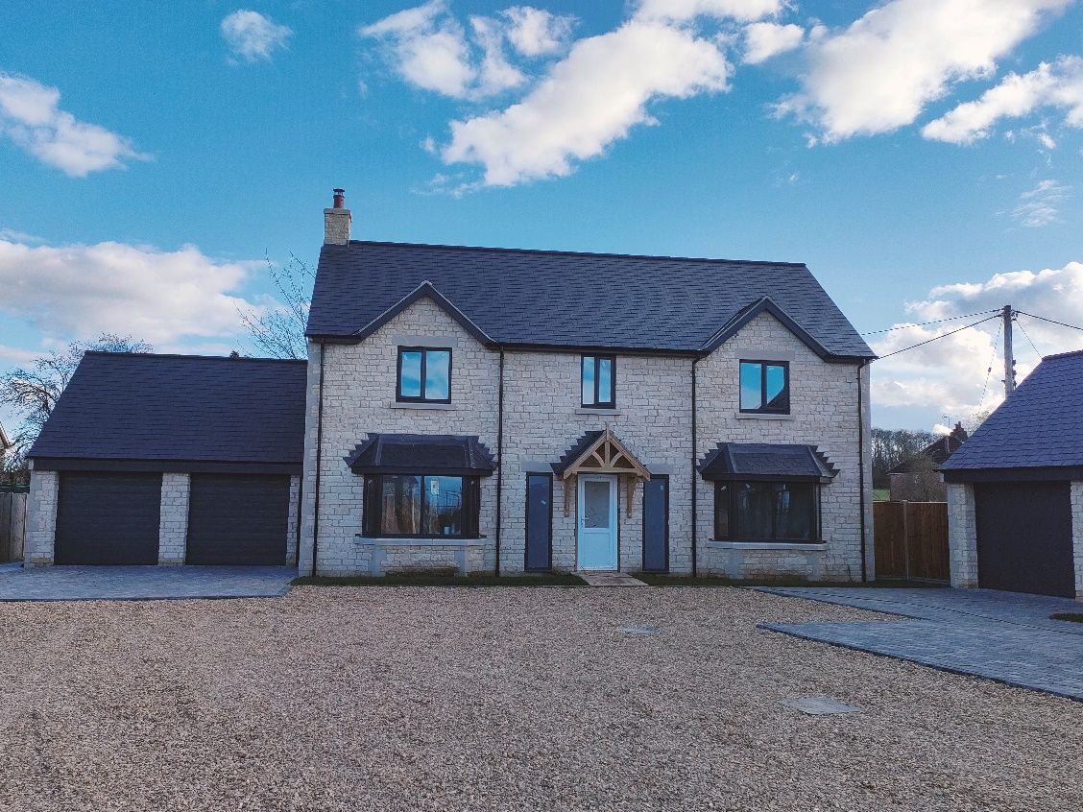
Note – as home 12 is currently under construction, the photograph above shows a recently completed home of a similar design built by City Builders (UK) Ltd
Set back from the Oundle Road in the quiet rural hamlet of Chesterton, close to the A1 and the outskirts of Peterborough, the Lady Alexa is one of only 5 luxury detached stone-built homes set around a secluded cul-de sac adjacent to Manor Farm.
This hidden jewel is tucked away at the end of a mature tree-lined private driveway, with open rolling countryside views to the rear and in the shadow of the ancient church of St Michael. Manor Gardens promises to be the home you’ve always dreamed of.
This development has been created by reputable local architects, DT Architects and is being constructed by local family-run City Builders (UK) Ltd to a high contemporary standard.
five generous double bedrooms, two with en suites
- substantial master bedroom with en suite shower room & walk-in wardrobe
- large open contemporary kitchen with family room & utility
- spacious double garage with power, light & remotely-operated electric doors
- underfloor heating to ground floor
- highly efficient air source heating system
- CALL 07873 604116 for an appt to view or to discuss your needs

Set in the corner of a small and secluded private cul de sac, the Lady Alexa offers luxury accommodation for the most discerning of buyers

Enter through a front door with glazed side panels, under a porched roof, into the

Large & welcoming Hallway including stairs to the first floor and a Cloakroom with contemporary wall-mounted wc and wash hand basin. Finished with engineered Oak flooring
Study (3.4m x 2.8m) with bay window for maximum light and ample sockets
Through Lounge (4m x 6.2m) featuring stone designer fireplace, patio doors to rear & bay window
Spacious Kitchen/Family Room (5.1m x 9m) light and airy with a generous range of wall & floor Kitchen units provided by Priory Kitchens and including integrated washing machine, fridge freezer, dishwasher, double oven and ceramic hob with downdraft extractor within a large island unit. Quartz worktops with matching upstands. Oversized bowl sink unit & mixer tap. Tiled ceramic flooring and down lighters. Bi-fold/sliding doors to rear garden and door to
Utility Room (2.5m x 1.9m) with a range of floor and wall units, tiled ceramic floor, sink unit, door to rear garden

Stairs to the large first floor landing with airing cupboard off

Master Bedroom (3.4m x 5.6m) with spacious walk-in wardrobe with rail and shelving and en suite Shower Room comprising wall-mounted wc, inset hand basin and over-sized walk-in shower cubicle with power shower and sliding doors. Full height tiling to shower and back wall.
Bedroom 2 (3.9m x 3.2m) a double bedroom with en suite Shower Room comprising wall-mounted wc, inset wash hand basin and walk-in shower cubicle with power shower. Full height tiling to shower and half tiled on all other walls
Bedroom 3 (4m x 2.9m) a large double bedroom
Bedroom 4 (3.2m x 2.9m) a double bedroom with built in cupboard (dimensions to be confirmed)
Bedroom 5 (2.9m x 3.1m) a double bedroom
Family Bathroom a spacious room with “his and hers” inset wash hand basins, wall-mounted wc effect towel rail and contemporary bath with hand-held shower over.

To the exterior
The Lady Alexa includes a Detached Double Garage accessed via a private driveway and benefits from a planted front garden, double-width slabbed footpath to the front door and gravelled driveway.
The ample rear garden will be seeded and will include a substantial patio area accessed from the Family Room and Lounge. The side garden offers open countryside views to the west and the Builder is not aware of any intention to build further homes in this field. An external water tap will be provided.
The Double Detached Garage includes an electronic remotely-controlled double up-and-over garage door, power and light and stairs to the first floor. For an additional fee (depending on specification), the first floor can be converted to a Live/Work Studio.

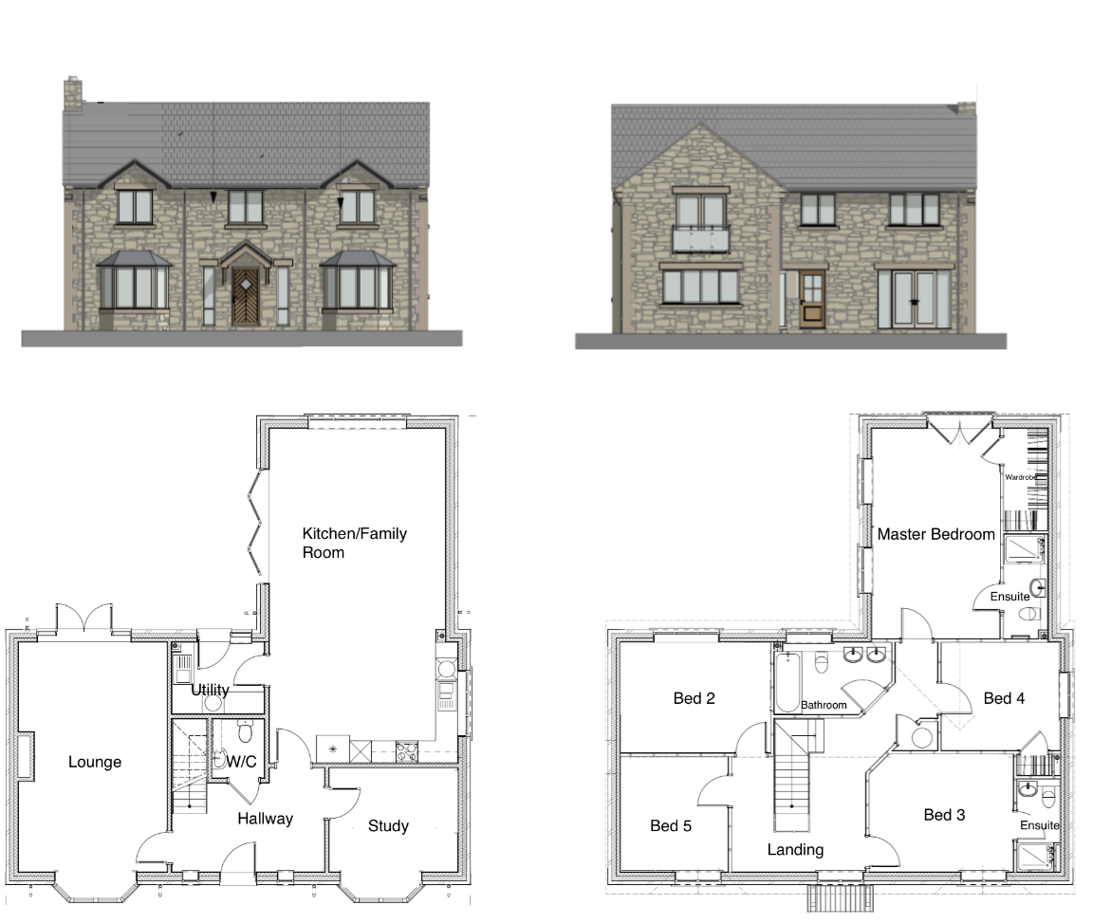

Location: exit the A1 at the Alwalton/Elton junction, about a mile north of Peterborough services, and head west towards Elton. Manor Gardens can be found on your right about 100m along the Oundle Road in the hamlet of Chesterton
Use postcode PE7 3UA on Satnav

Things you need to know
The homes at Manor Gardens will be freehold although a private management company is being formed to maintain the access road, verges and communal bin areas.
As no natural gas is available in this location, an air source heat pump system will be installed and full instruction will be given on its optimum use.
Homes 9 to 13 are the first phase of development and planning has been granted for a further 7 courtyard homes off of a separate drive. There is the potential to apply for a further 7 homes with separate access, to the north of home 13, at a later date and so far as CBUK are aware, no further expansion is planned
The homes will be warranted by ICW including structural protection for 10 years with a 2-year initial defects period. Full details will be provided to your solicitor and the warranty is accepted by the majority of major lending institutes. City Builders (UK) ltd fully support the ICW consumer’s code of conduct policy.
Please do not visit Manor Gardens without a prior appointment. HSE policies and Covid guidance will be given prior to access being allowed onto the development. CBUK reserve the right not to allow access or to terminate an appointment if anyone does not follow their HSE/Covid policies.
A non-refundable reservation fee of £1500 will be required to secure a home at Manor Gardens and, once cleared, the home will be removed from the open market for 8 weeks to allow for an exchange of contracts.
Estimated completion dates will be given in good faith on reservation and every effort will be made to meet that date. CBUK cannot allow for time lags or availability in material deliveries but we will ensure that all buyers are regularly informed of any potential delays
City Builders (UK) Ltd pride themselves on working with home-buyers to personalise their new home to their wants, needs and dreams. Subject to build stage and on the proviso that they cannot entertain amendments or upgrades that would require a revised planning consent or making any internal structural changes, they can provide fixed quotations for most things which can either be paid for in advance (and would be non-refundable), prior to the requisite build stage when such extras need to be ordered, or can be added to the final account if contracts have been exchanged prior to the requisite build stage.
Whilst CBUK do offer a high quality and comprehensive specification, enhancements that could be considered would include creating studios over garages, extending or upgrading wall and floor tiling, upgrading or re-designing Kitchens, personalising paint colours, upgrading intruder alarm systems, increasing electric sockets or lighting points, hard-wiring a computer network or creating a wet room. Just ask, they can’t always say yes, but they do try to meet their buyers’ needs.

CBUK have endeavoured to ensure that the information in these details is accurate and reliable. It must not be relied on as statements or representations of fact as the information does not constitute any part of an offer or contract. The sellers do not make any representation or give any such warranty in relation to the property. We strongly recommend that all the information that is provided about each property is verified by yourself or your advisors. The final specification will be detailed on reservation and CBUK reserve the right to substitute any part of the specification with an alternative of equal or higher value should any material not be available at the time required.
Systems will be tested and certified on completion and all appliances will be installed with manufacturer’s warranty and buyers must register that warranty in their own name.
All information obtained by us is solely for the use of CBUK and is not given out to any third party.
City Builders (UK) Ltd Sept 2021 Registered Office - 8 Priory Gardens, Chesterton, Peterborough, PE7 3UB

